PROJECT REPORT:

EGG POWDER MANUFACTURING UNIT

1. Egg Powder:
Egg powder is a dehydrated form of eggs, mainly used in bakeries, fast food, hotels, pharmaceuticals, and food manufacturing. It includes:
- Whole Egg Powder
- Egg Yolk Powder
- Egg White Powder
Each type serves different industries.

2. Global Egg Powder Market Overview
- Valuation:
  - In 2023, the global egg powder market was valued around USD 2.2 billion.
  - Expected to reach USD 3.5 billion by 2030 growing at about 6% CAGR.
- Drivers:
  - Rising demand in processed foods, bakery, and cosmetics.
  - Longer shelf life compared to fresh eggs.
  - Convenience in transportation and storage.

3. Egg Powder Market in Pakistan
- Size:
  - Pakistan produces over 20 billion eggs annually (Poultry Association of Pakistan).
  - Egg processing (for powder) is still a growing market, very limited players — huge potential.
- Demand:
  - Food industry, pharmaceuticals, hotels (HORECA), and exports to Gulf countries.
- Opportunity:
  - Since few companies are in this segment, setting up a plant gives a first-mover advantage for local and export markets.

4. Egg Powder Manufacturing Process (Machines Involved)
Step-by-step method:
- Egg Reception & Quality Check
  - Machine: Conveyor, grading system.
- Washing & Sanitizing
  - Machine: Egg washer.
- Breaking and Separation
  - Machine: Egg breaker (automatically separates shell, yolk, white).
- Filtration
  - Machine: Egg liquid filter (removes membranes, shell bits).
- Blending
  - Homogenizer for even mixing.
- Pasteurization
  - Machine: Pasteurizer (kills bacteria without cooking the egg).
- Spray Drying
  - Machine: Spray dryer (main machine) — converts liquid egg into powder instantly by blowing hot air.
- Sieving
  - Machine: Vibrating sieve.
- Packaging
  - Machine: Automatic packing system.

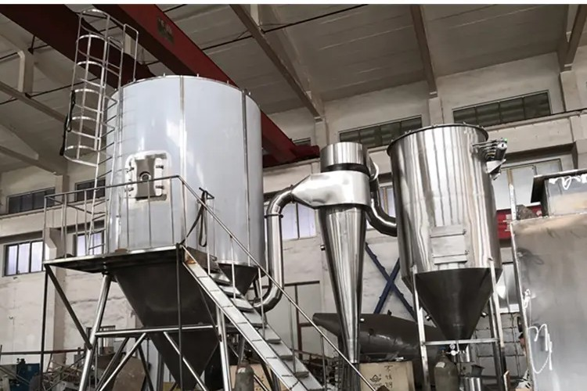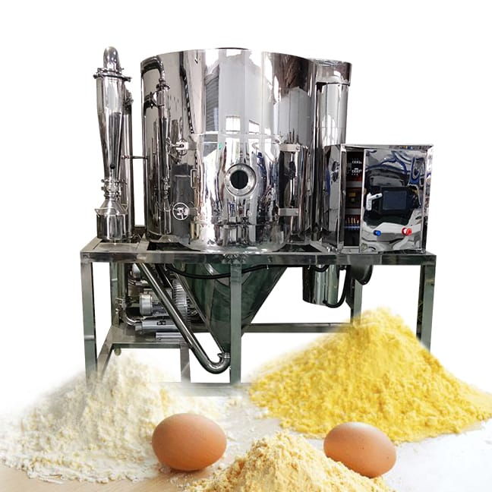

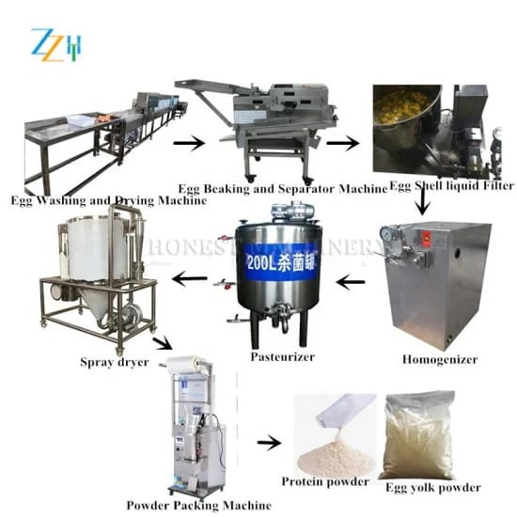

5. Egg Shell Use
- Applications:
  - Calcium supplements (after grinding).
  - Fertilizer (crushed shells improve soil).
  - Animal feed additives.
- You can set up a separate line to crush eggshells into calcium powder (additional profit).

6. Egg Powder Use
- Bakery industry (cakes, pastries, bread).
- Instant food industry (noodles, snacks).
- Pharmaceuticals (supplements).
- Cosmetics (egg proteins in beauty products).
- Pet food and livestock feed.

7. Expiry/Shelf Life of Egg Powder
- Unopened & properly stored (in dry, cool conditions):
  - 12 to 24 months.
- After opening, if not used within 1-2 months, quality can degrade.
- Must use air-tight, moisture-proof packaging.

8. Types of Egg Powder
- Whole Egg Powder: Yolk + White mixed. (Used for baking, mayonnaise, pasta)
- Egg Yolk Powder: Only yolk. (Sauces, dressings, desserts)
- Egg White Powder: Only white. (Protein powders, bakery, pharmaceuticals)

9. Summary of Machines Needed
Step | Machine
Receiving | Conveyor & Grader
Washing | Egg Washer
Breaking | Egg Breaker & Separator
Filtering | Liquid Egg Filter
Pasteurizing | Pasteurizer
Drying | Spray Dryer
Sieving | Vibrating Sieve
Packaging | Auto Packing Machine

10. Additional Advice
- Investment: For a small-medium plant (around 5000 eggs/hour), basic setup cost in Pakistan could be around PKR 30 to 50 million.
- Certification: Get ISO, Halal certification to access local and Gulf markets.
- Export Markets: UAE, Saudi Arabia, Qatar, Malaysia are big buyers of halal-certified egg powder.
  - Layout of a Typical Egg Powder Factory
Here’s a simple production flow for your plant:

Support Areas:
- Quality Control Lab
- Utilities Room (Boilers, Compressors)
- Office Block
- Staff Changing Room
- Waste Management (for eggshells)
General Tips:
- Separate dirty and clean zones (hygiene standards).
- Proper ventilation is very important near spray dryer.
- Flooring must be sloped for easy cleaning.
  - List of Chinese Companies (Machine Suppliers)
Here are trusted suppliers known for egg powder production lines:
Company Name | Specialty | Website/Contact Info
- Shanghai Jump Machinery Co., Ltd. | Egg processing & spray dryers | jumpfruits.com
- Zhengzhou Longer Machinery | Full egg powder lines | longerinc.com
- Shanghai Genyond Technology | Egg & food processing lines | genyond.en.alibaba.com
- Zhengzhou Alpha Machinery | Egg powder & spray dryers | alphamachinery.cn
- Gofun Machinery | Food drying systems | gofunmachine.com

  - Basic Business Plan Outline for Egg Powder Industry

Here’s a simple business plan structure you can follow:

Market Analysis
- Current egg production stats in Pakistan.
- Growing demand for processed foods, pharmaceuticals, bakery sector.
- Export potential.

Products & Services
- Whole Egg Powder (main product)
- Yolk Powder
- Egg White Powder
- Crushed Eggshell Calcium Powder (Optional)

Operations Plan
- Daily capacity: e.g., 20,000 eggs/day.
- Machine suppliers: (e.g., Shanghai Jump Machinery).
- Workforce: Machine operators, QA manager, packaging workers.

Marketing & Sales Strategy
- Sell to:
  - Food industries (local & Gulf).
  - Bakeries, Hotels, Fast Food chains.
  - Pharma industries (capsules/supplements).
- Attend food expos (e.g., Gulf Food Expo, Karachi Food Tech).

Financial Plan
- Initial Investment: ~PKR 30–50 million
- Main Expenses:
  - Machines and installation
  - Factory rent/land
  - Raw material (eggs)
  - Staff salaries
  - Utility costs (electricity, gas)
- Revenue Sources:
  - Local B2B sales
  - Export sales to UAE, Saudi Arabia, Malaysia
- Break-even: Estimate in 2–3 years.

Legal Requirements
- SECP Company Registration.
- FBR NTN Registration.
- Food Authority License (Punjab Food Authority, etc.).
- ISO 22000 / Halal certification for export.

Risk Analysis
- Raw egg price fluctuations.
- Power shortages (suggest generator backup).
- Export restrictions (keep eye on government policies).
  - Extra Tip: Investment Options
If you have lower budget, you can:
- Start with only Egg White Powder production first (low complexity).
- Partner with poultry farms for constant egg supply.
If you have higher budget, you can:
- Build a fully automatic line with spray dryer and packaging.
- Set up solar panels for factory electricity.
  - Basic Assumptions
Let's assume you're making Whole Egg Powder:
- Raw Material (Eggs):
  - 1 kg of whole egg powder needs about 3.8–4 kg of fresh eggs.
  - In Pakistan, egg price (bulk poultry farm rate) = ~PKR 220–260 per dozen.
  - 1 dozen (12 eggs) ≈ 0.65–0.7 kg eggs weight.

- Egg Price Calculation:
  - 1 dozen = 12 eggs = ~0.7 kg
  - 1 kg eggs = about 17–18 eggs = around PKR 320–350 (bulk rate).
- Other Costs:
  - Utilities (electricity, gas, water): ~PKR 50–70 per kg powder.
  - Packaging material (airtight foil pouches): ~PKR 30–40 per kg.
  - Labor + Overhead: ~PKR 30 per kg.
  - Depreciation (machines, building): minimal per kg, say PKR 10.
- Total Production Cost per kg:
Raw Material + Utilities + Packaging + Labor + Depreciation
= (PKR 320 x 4) + 50 + 40 + 30 + 10
= PKR 1,380–1,400 per kg (approx.)
  - Selling Price
Market | Price per Kg
Local Market (Bakeries, Food Factories) | PKR 1,800–2,000
Export (UAE, Saudi, Malaysia) | PKR 2,200–2,600

(Price depends on purity, certification, and packaging.)
  - Profit Margin Calculation
Local Sale Example:
- Cost: ~PKR 1,400 per kg
- Sale price: ~PKR 1,900 per kg
- Gross Profit = 1,900 - 1,400 = PKR 500 per kg
Profit Margin % = (Profit / Cost) x 100
= (500 / 1400) x 100
= 35.7% margin
Export Sale Example:
- Cost: ~PKR 1,400 per kg
- Sale price: ~PKR 2,400 per kg
- Gross Profit = 2,400 - 1,400 = PKR 1,000 per kg
Profit Margin % = (Profit / Cost) x 100
= (1000 / 1400) x 100
= 71.4% margin
  - In Short
Sale Type | Profit per Kg | Profit Margin
Local Sale | PKR 500 | 35–40%
Export Sale | PKR 1,000 | 70–75%
  - Important Factors That Impact Profit
- Raw Egg Rates: Lower egg prices = higher profit. Best to contract directly with poultry farms.
- Efficiency of Machines: Good spray dryers reduce energy cost.
- Certification: ISO & Halal certification increases export prices.
- Packaging Quality: Good packaging allows you to charge premium price.

Quick Tip
If you start small (say 200 kg of egg powder/day):
- Daily profit (local) = 200 × 500 = PKR 100,000/day
- Monthly profit (25 days) = PKR 2.5 million
- Yearly = ~PKR 30 million (before tax)
In export sales, double this figure!
  - Pakistan Corporate Tax Scenario (2025)
- If you register your company normally (Private Limited):
  - Income Tax Rate = 29% on Net Profit.
- If you register under SME (Small & Medium Enterprise) Policy (available for manufacturing units):
  - Income Tax Rate = 15%–20% (depending on size).
(I’ll show both cases below so you understand clearly.)
  - Example Profit Before Tax
From my previous message:
- Suppose daily production = 200 kg
- Profit per kg (local sale) = PKR 500
So:
- Daily Gross Profit = 200 × 500 = PKR 100,000
- Monthly Gross Profit (25 working days) = 100,000 × 25 = PKR 2.5 million
- Yearly Gross Profit = 2.5m × 12 = PKR 30 million
  - After-Tax Profit (Normal Tax 29%)
First, deduct 29% tax:
- Tax Payable = 30 million × 29% = PKR 8.7 million
- After-Tax Profit = 30m - 8.7m = PKR 21.3 million/year
  - After-Tax Profit (SME Manufacturing Tax 15%)
If you register under SME policy:
- Tax Payable = 30 million × 15% = PKR 4.5 million
- After-Tax Profit = 30m - 4.5m = PKR 25.5 million/year

  - Quick Table for Summary
Situation | Annual Gross Profit | Tax Rate | Tax Amount | Net Profit (After Tax)
Normal Pvt Ltd Company | PKR 30 million | 29% | 8.7 million | PKR 21.3 million
SME Registered Company | PKR 30 million | 15% | 4.5 million | PKR 25.5 million
  - Important
- SME registration is highly recommended — big tax saving!
- You must apply under Manufacturing SME Category with FBR + SECP during setup.
- Also, claim depreciation expense on machinery, land rent, salaries etc. — further reduces taxable income legally!
Conclusion:
The egg powder industry presents a strong business opportunity in Pakistan, backed by rising global demand, limited local competition, and excellent export potential. With an investment of around PKR 30–50 million, and by setting up an efficient production unit using Chinese machinery, entrepreneurs can achieve attractive profit margins of 35–75%, depending on sales strategy. Registering under the SME policy and securing quality certifications (ISO, Halal) will maximize profitability, reduce taxes, and open doors to international markets. Careful planning of factory layout, operations, and raw material sourcing is essential for long-term success.

